Discourse #14

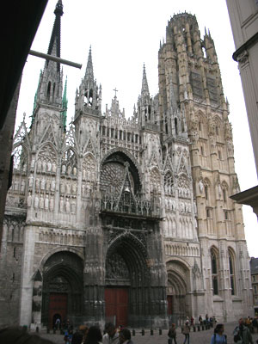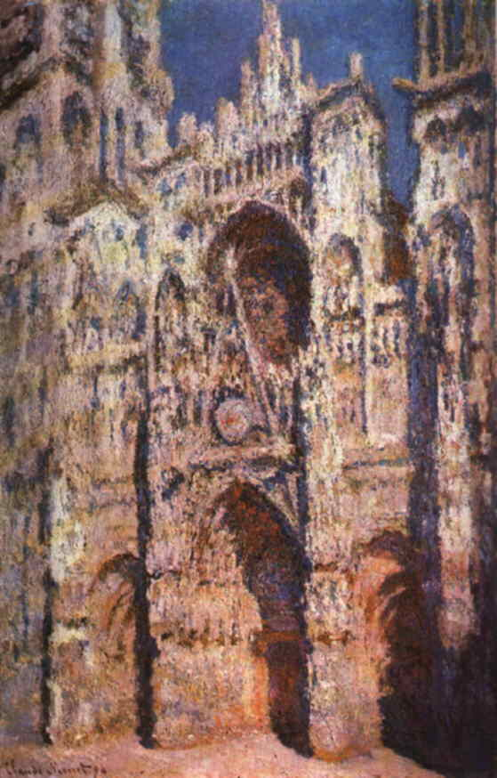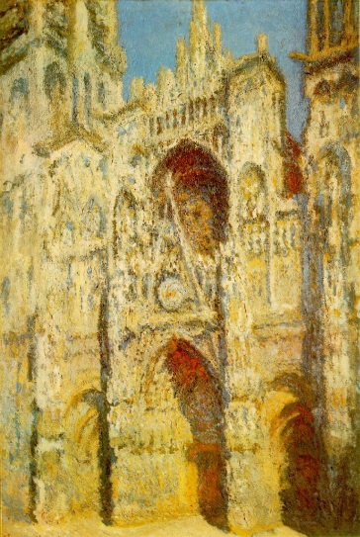
Rouen Cathedral Rouen Cathedral Rouen Cathedral
(photo) (Monet/painting) (Monet/painting)

Using the paintings above discuss the concerns of the Impressionist painter, Monet. What did he set out to accomplish in painting Rouen Cathedral over and over again? In your essay use the correct terms for the architectural structures of the Gothic Cathedral found in your textbook to describe the colors in the two paintings; façade, pointed arches, portal, spires. Please do not include the Gothic architectural structures inside the cathedral. I am only interested in you describing the color on the structures that I included here. If you do not compare and contrast the colors in the two paintings by naming them, you are missing the point of Impressionism. I included a photo of Rouen Cathedral, not to confuse you, but simply for you to see.

